**PRESS RELEASE**

**COMMUNICATIONS AND MEDIA TEAM OF THE 2023 ASEAN SUMMIT**

**No. 64/SP/TKM-ASEAN2023/ENG/5/2023**

**Puncak Waringin Offers Beautiful Labuan Bajo Scenery for the 42nd ASEAN Summit Spouse Program**

**West Manggarai, May 10, 2023** – Indonesian First Lady Iriana Joko “Jokowi” Widodo with a warm smile welcomed the arrival of ASEAN leaders' spouses at Puncak Waringin, West Manggarai Regency, East Nusa Tenggara (NTT).

The Spouse Program was attended by Bun Rany Hun Sen from Cambodia, Vandara Siphandone from Lao PDR, Wan Azizah Wan Ismail from Malaysia, Louise Araneta Marcos from the Philippines, and Ho Ching from Singapore.

After extending a welcome and shaking hands with Iriana, the leaders’ spouses headed to the waiting room that had been prepared. In the waiting room, Expert staff for Sociocultural Affairs and Empowerment of Overseas Indonesian Communities at the Foreign Affairs Ministry Siti Nugraha Mauludiah and wife of East Nusa Tenggara Province (NTT) Governor Julie Sutrisno Laiskodat accompanied ASEAN Leaders’ spouses watching a weaving process of East Nusa Tenggara’s traditional fabrics.

The Spouse Program which was held at Puncak Waringin, Wednesday morning,10 May, was part of the series of the 42nd ASEAN Summit 2023. The event coincided with the opening of the 42nd ASEAN Summit 2023 at the Hotel Meruorah, Labuan Bajo, West Manggarai.

After watching the weaving process of East Nusa Tenggara’s fabrics, Iriana, dressed in a pink national attire combined with Flores woven fabric, invited the ASEAN leaders' spouses to watch other cultural activities, including Dundundake dance performance, the Rangkuk Alu traditional game played by Labuan Bajo Vocational School students, and East Nusa Tenggara Province (NTT)’s traditional songs.

Iriana Jokowi together with spouses of the ASEAN leaders then rode a buggy car to the 2nd floor of Puncak Waringin to see a number of products from local micro, small, and medium enterprises (MSMEs), such as woven fabrics, coffee, and processed moringa leaves.

"I can feel that all of you will be happy to see what's in Labuan Bajo," said Iriana as quoted from the Presidential Secretariat Press Bureau release.

The First Lady of the Republic of Indonesia told the Spouses that Labuan Bajo is the gateway to Komodo Island, the habitat of Indonesia's endemic fauna, the Komodo dragon. She also explained that the Komodo dragon is a species of large lizard that can weigh up to 160 kilograms and have a body length of up to three meters.

" If you come too close, it can be dangerous, but if you want it, you can see later," said Iriana Jokowi.

On that occasion, she also told her guests about the location of the spouse program, Puncak Waringin, which is usually used as a creative hub for East Nusa Tenggara creative economy actors. This location was inaugurated by the President of the Republic of Indonesia in October 2021.

"This place will be developed as a creative hub, a center for culture-based creative economic activities," she said.

In her remarks, Iriana hoped that the ASEAN leaders' spouses would enjoy their time in Labuan Bajo.

They are also expected to play the roles to maintain relations between ASEAN peoples and advancing women in ASEAN.

She also hoped that the spouses of ASEAN leaders will be at the forefront in strengthening ASEAN people-to-people relations and the advancement of women in Southeast Asia,” she added.

The activity was closed with a tea banquet. Songs from countries in Southeast Asia, including regional songs of East Nusa Tenggara, were sung during the tea party while enjoying the view of the blue sea of Labuan Bajo. They also took the opportunity to pose for family photos.

The spouse program is also a momentum to introduce Labuan Bajo and East Nusa Tenggara’s products to ASEAN and the world. An Indonesian state-owned company, PT Sarinah, also showcased 30 local products in the Spouse Program.

"There are several food and beverage products such as tea, coffee, as well as woven fabrics, fashion, accessories, and home décor accessories," said Sarinah President Director, Fetty Kwartati, in Labuan Bajo, Wednesday, 10 May.

The state-owned company engaged in retail and trade sector has curated more than 100 MSME products. Sarinah together with the Regional National Crafts Council (Dekranasda) of NTT Province was tasked to curate and display MSME products, especially from NTT for the ASEAN Summit Spouse Program.

Furthermore, Fetty Kwartati said the products curated for the Spouse Program had several criteria, namely using environmentally friendly materials combined with attractive designs. "It becomes a very beautiful product and can be purchased directly and used daily," she said. (Kristantyo Wisnubroto/Elvira Inda Sari/TR/UG)

***

For more information, please contact:

**Director General of Public Information and Communications of the Ministry of Communications and Informatics – Usman Kansong (0816785320).**

Get more information at <http://asean2023.id>, <https://infopublik.id/kategori/asean-2023>, and <https://indonesia.go.id/kategori/ragam-asean-2023>

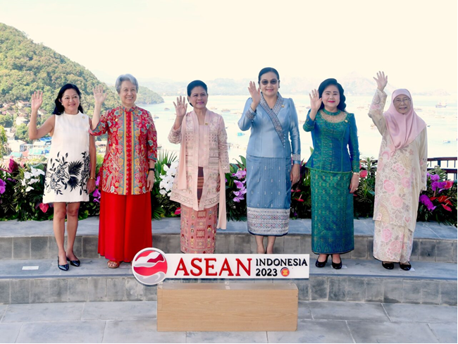

Mrs. Iriana Joko Widodo hosting a tea banquet with ASEAN leaders' Spouses on the 2nd floor of Puncak Waringin, West Manggarai Regency, East Nusa Tenggara (NTT), on Wednesday, 10 May 2023. (Photo: BPMI)

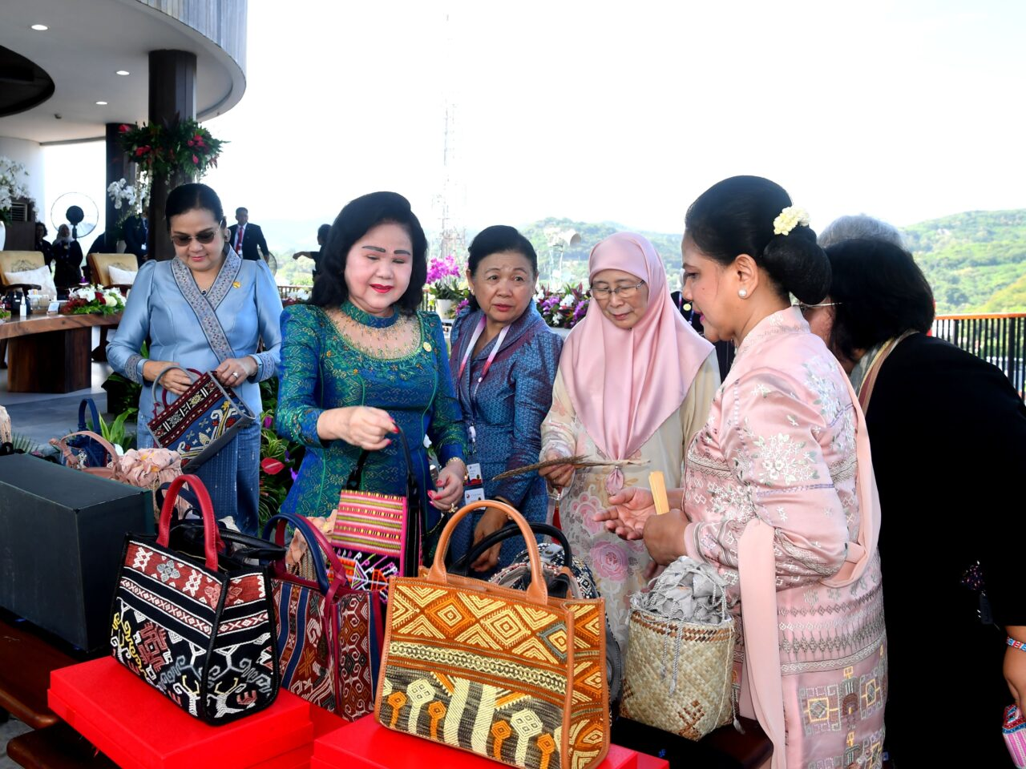

Mrs. Iriana Joko Widodo hosting a tea banquet with ASEAN leaders' Spouses on the 2nd floor of Puncak Waringin, West Manggarai Regency, East Nusa Tenggara (NTT), on Wednesday, 10 May 2023. (Photo: BPMI)

